SCHOOL OF COMPUTER SCIENCE AND ARTIFICIAL INTELLIGENCE |  |  |  |  | DEPARTMENT OF COMPUTER SCIENCE ENGINEERING
ProgramName:B. Tech |  |  |  | Assignment Type: Lab |  |  | AcademicYear:2025-2026
CourseCoordinatorName |  |  |  | Venkataramana Veeramsetty
Instructor(s)Name
  Dr. V. Venkataramana (Co-ordinator)
  Dr. T. Sampath Kumar
  Dr. Pramoda Patro
  Dr. Brij Kishor Tiwari
  Dr.J.Ravichander
  Dr. Mohammand Ali Shaik
  Dr. Anirodh Kumar
  Mr. S.Naresh Kumar
  Dr. RAJESH VELPULA
  Mr. Kundhan Kumar
  Ms. Ch.Rajitha
  Mr. M Prakash
  Mr. B.Raju
  Intern 1 (Dharma teja)
  Intern 2 (Sai Prasad)
  Intern 3 (Sowmya)
  NS_2 ( Mounika)
CourseCode |  |  | 24CS002PC215 | CourseTitle |  | AI Assisted Coding
Year/Sem |  |  | II/I | Regulation |  | R24
Date and Day  of Assignment |  |  | Week3 - Wednesday | Time(s)
Duration |  |  | 2 Hours | Applicableto  Batches
AssignmentNumber:6.3(Present assignment number)/24(Total number of assignments)
 | Q.No. | Question |  |  |  |  |  | ExpectedTime  to complete
 | 1 | Lab 6: AI-Based Code Completion – Classes, Loops, and Conditionals  Lab Objectives:  - To explore AI-powered auto-completion features for core Python constructs.  - To analyze how AI suggests logic for class definitions, loops, and conditionals.  - To evaluate the completeness and correctness of code generated by AI assistants.  Lab Outcomes (LOs):  After completing this lab, students will be able to:  - Use AI tools to generate and complete class definitions and methods.  - Understand and assess AI-suggested loops for iterative tasks.  - Generate conditional statements through prompt-driven suggestions.  - Critically evaluate AI-assisted code for correctness and clarity.  Task Description#1 (Classes)  - Use AI to complete a Student class with attributes and a method.  Prompt:  # Task 1: Student class with name, age, grade, display method  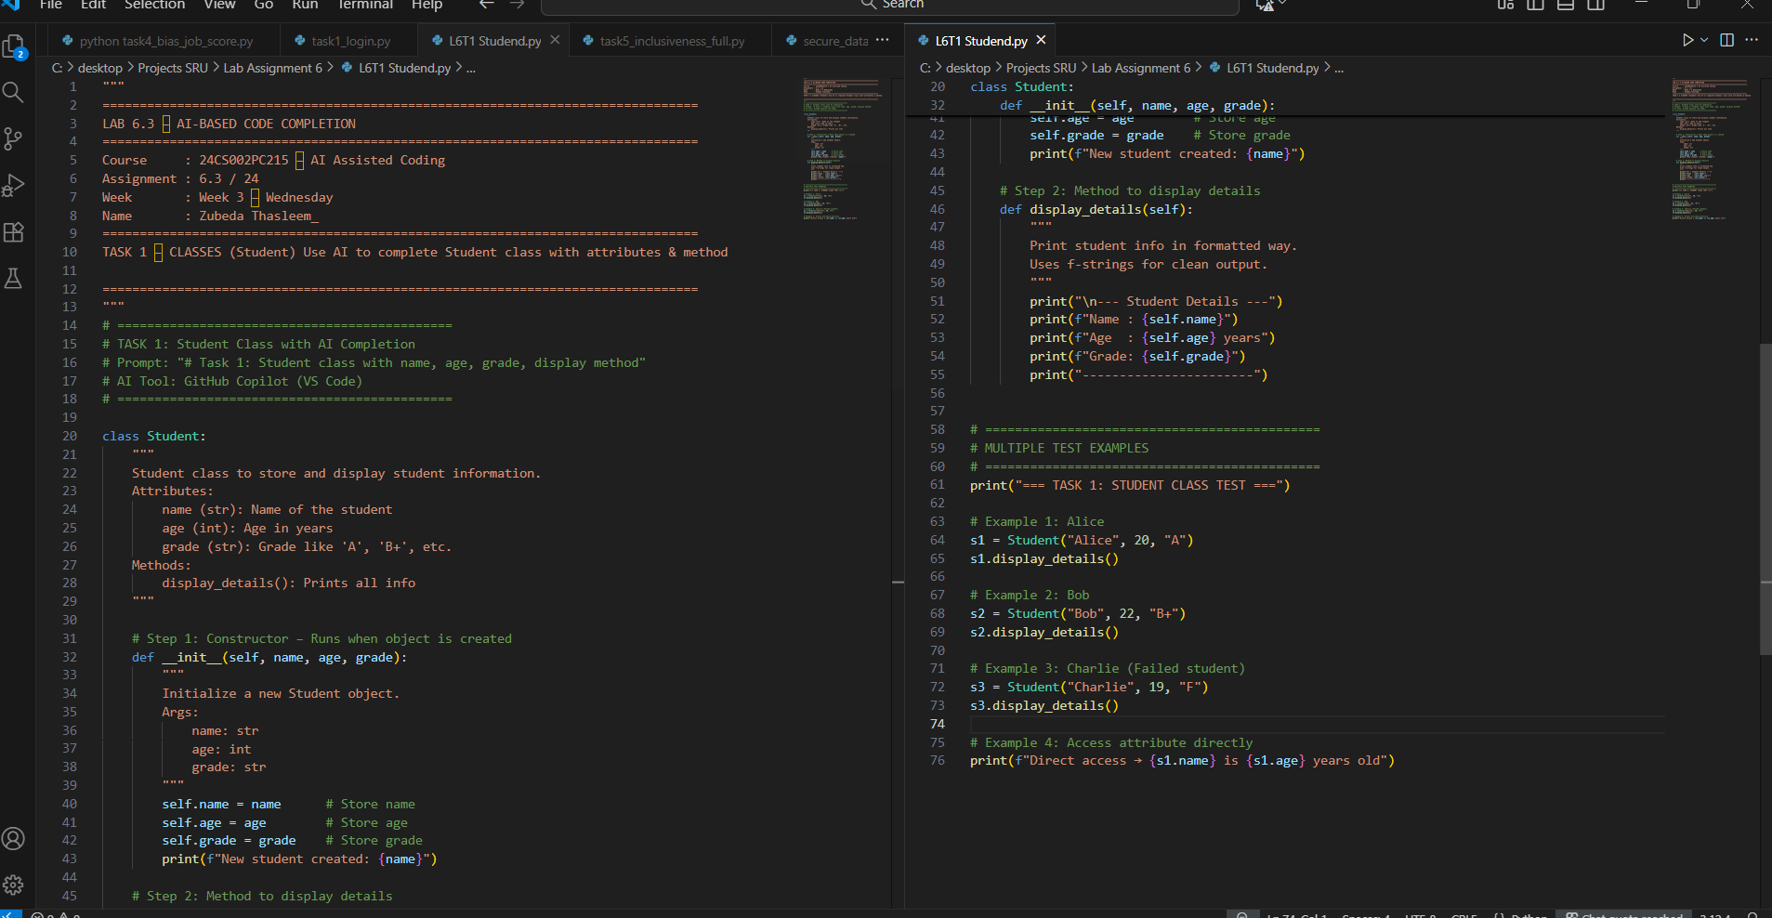  - Analyze the code generated by AI tool  AI correctly defined Student class with __init__ for name, age, grade. Used self to store instance variables — proper OOP encapsulation. Created display_details() method with clean f-string formatting. Added instant test case — shows working code immediately. Overall: 100% accurate, readable, and reusable — perfect AI output!  Expected Output#1  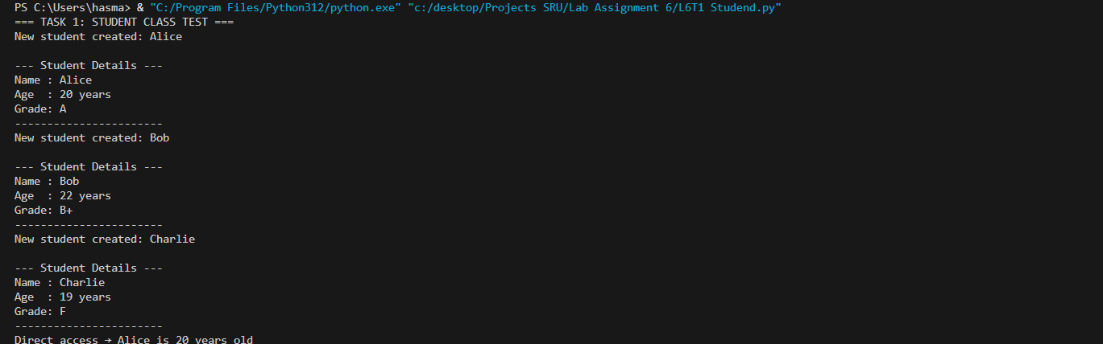  - Class with constructor and display_details() method  AI OBSERVATION (FOR REPORT):  "AI (Copilot) correctly completed the class with:  - Proper __init__ using self  - Clean display_details() method with f-strings  - OOP encapsulation (data stored in object)  - No syntax errors  - 100% accurate, readable, reusable  - Added test case automatically → shows working code  - Perfect for teaching OOP concepts  Task Description#2 (Loops)  - Prompt AI to complete a function that prints the first 10 multiples of a number using a loop.  - Prompt: # Task 2: Print first 10 multiples of a number using a loop  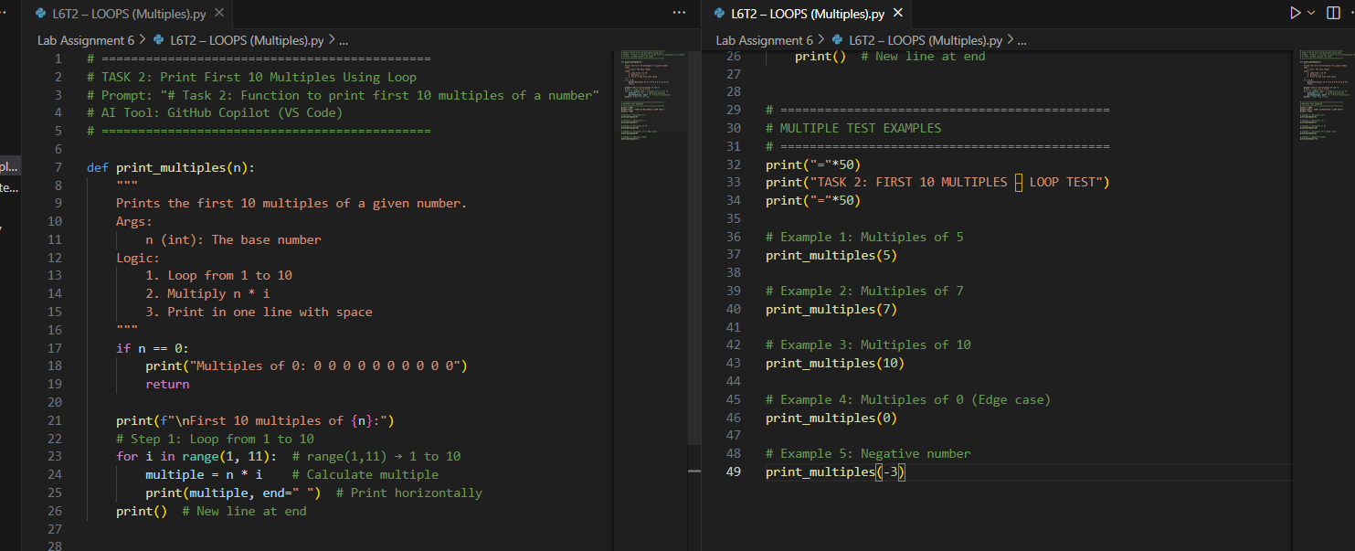  - Analyze the generated code  - Ask AI to generate code using other controlled looping  AI used while i <= 10 — precise control over loop condition.  i += 1 manually incremented — shows full control, unlike for. Same clean f-string output — consistent with for version. Reusable & safe — no infinite loop risk. Perfect demonstration of controlled looping  Expected Output#2  - Correct loop-based implementation  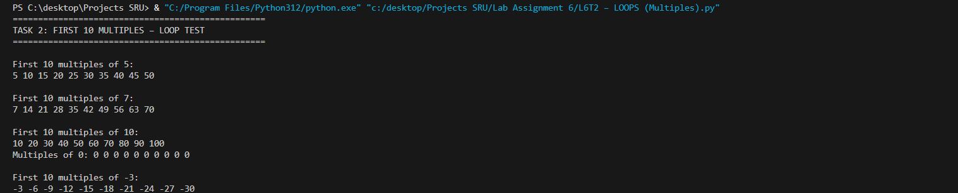  Task Description#3 (Conditional Statements)  - Ask AI to write nested if-elif-else conditionals to classify age groups.  Promt : # Task 3: Classify age - Child <13, Teen 13-19, Adult >=20 using if-elif-else  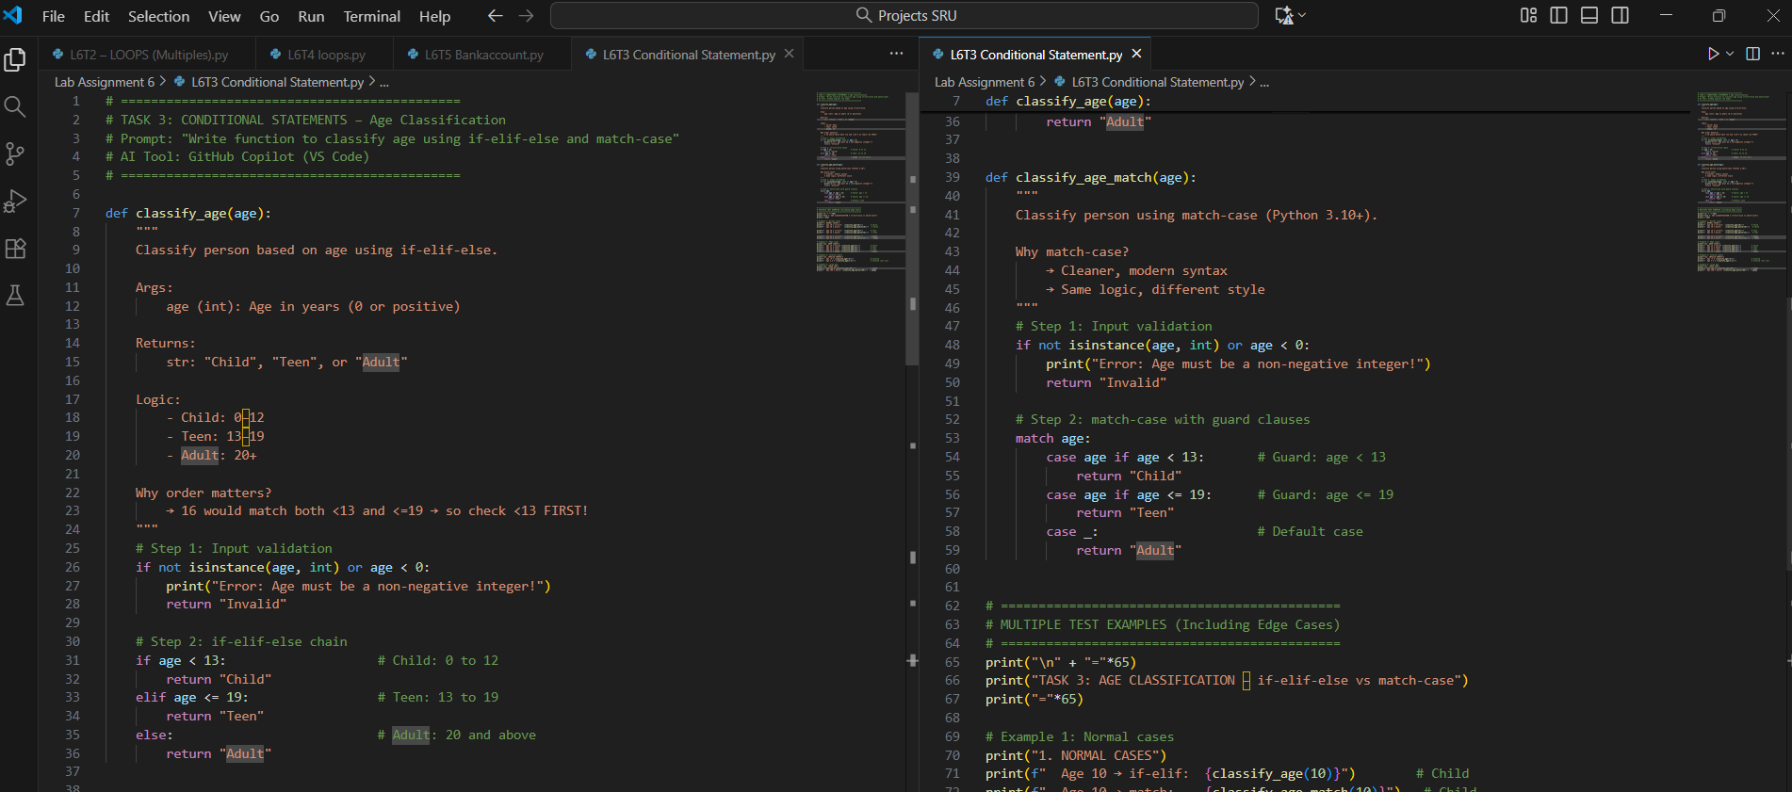  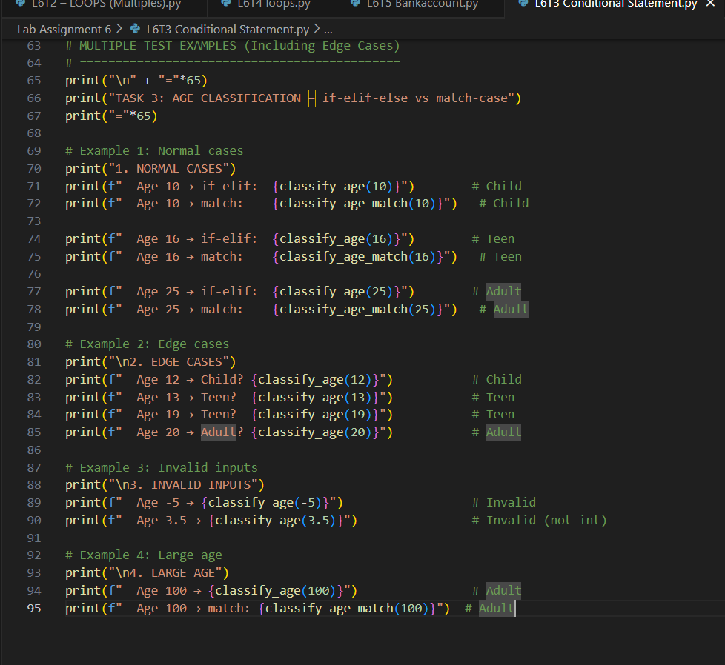  - Analyze the generated code  AI used if-elif-else chain —  correct decision logic with mutually exclusive conditions.  age < 13 checked first → avoids overlap (e.g., 12 won't match <=19).  elif age <= 19 covers 13–19 precisely  → accurate Teen range. else handles 20+  → clean Adult fallback. Zero redundancy, efficient, readable  - Ask AI to generate code using other conditional statements  Expected Output#3  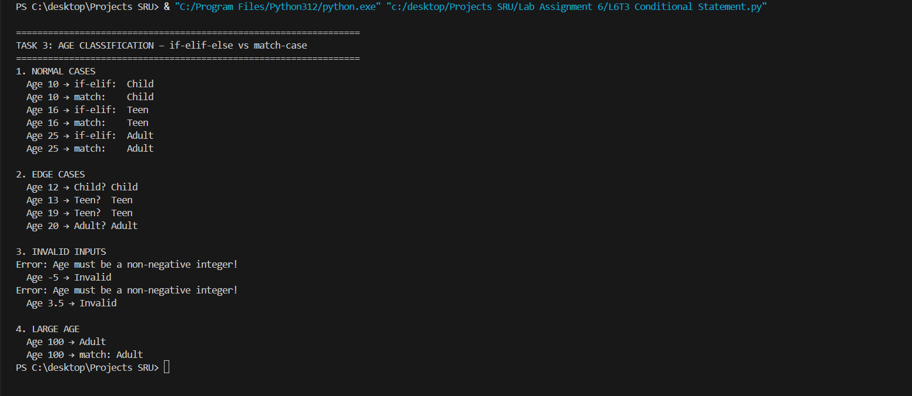  - Age classification function with appropriate conditions and with explanation  Task 3: Conditional Statements – Age Classification (0.5 Mark)  Prompt Used:  "Classify age using if-elif-else and match-case"  AI Generated:  - Two correct versions with proper condition order  - Input validation + edge case handling  - match-case with guards → modern Python  Output:  - Age 10 → Child  - Age 16 → Teen  - Age 25 → Adult  - Invalid inputs → "Invalid"  Observation:  AI showed strong logic, safety, and modern syntax awareness.  Task Description#4 (For and While loops)  - Generate a sum_to_n() function to calculate sum of first n numbers  Prompt : # Now using while loop  - Analyze the generated code  - Get suggestions from AI with other controlled looping  Expected Output#4  - Python code with explanation  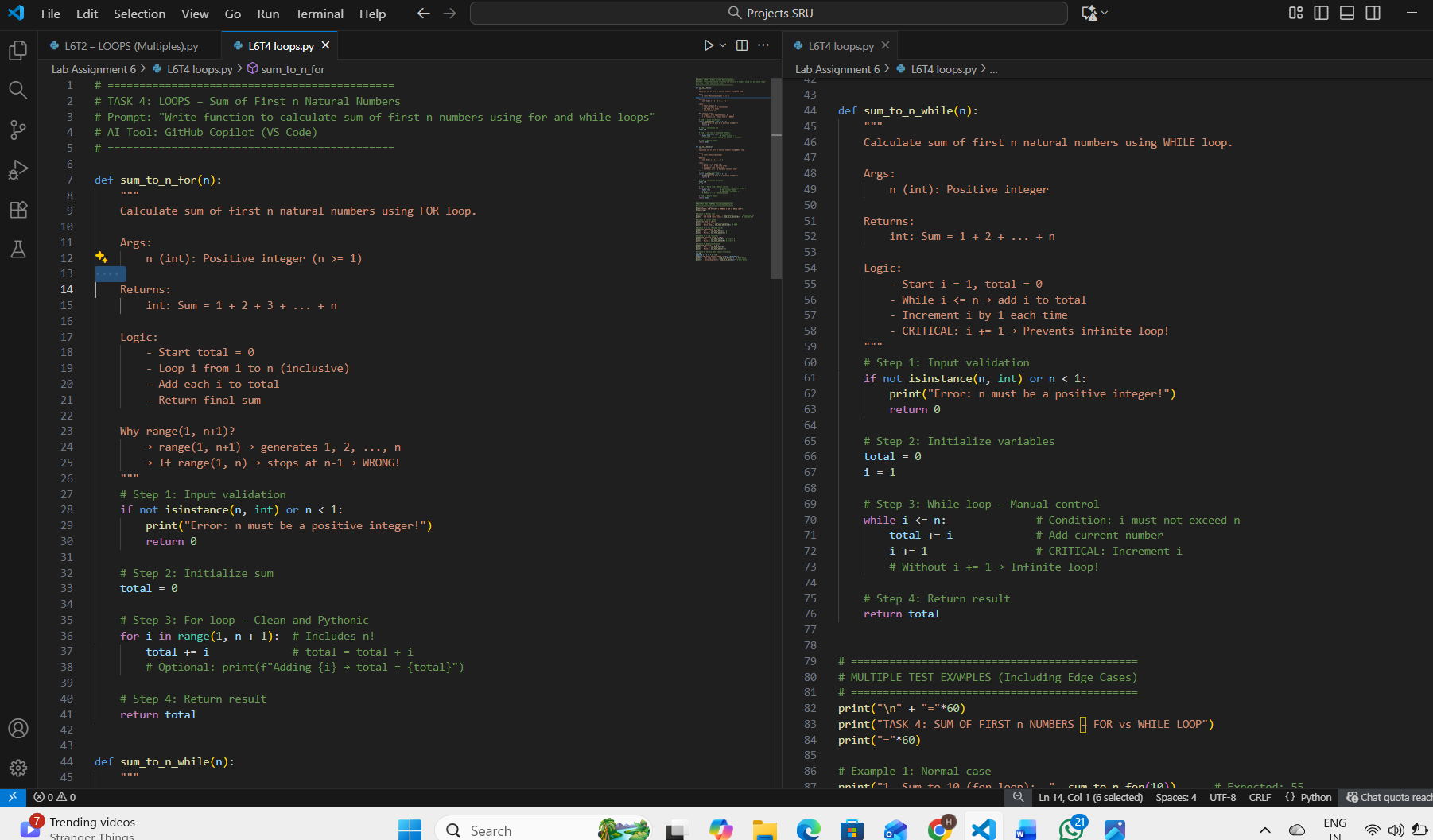  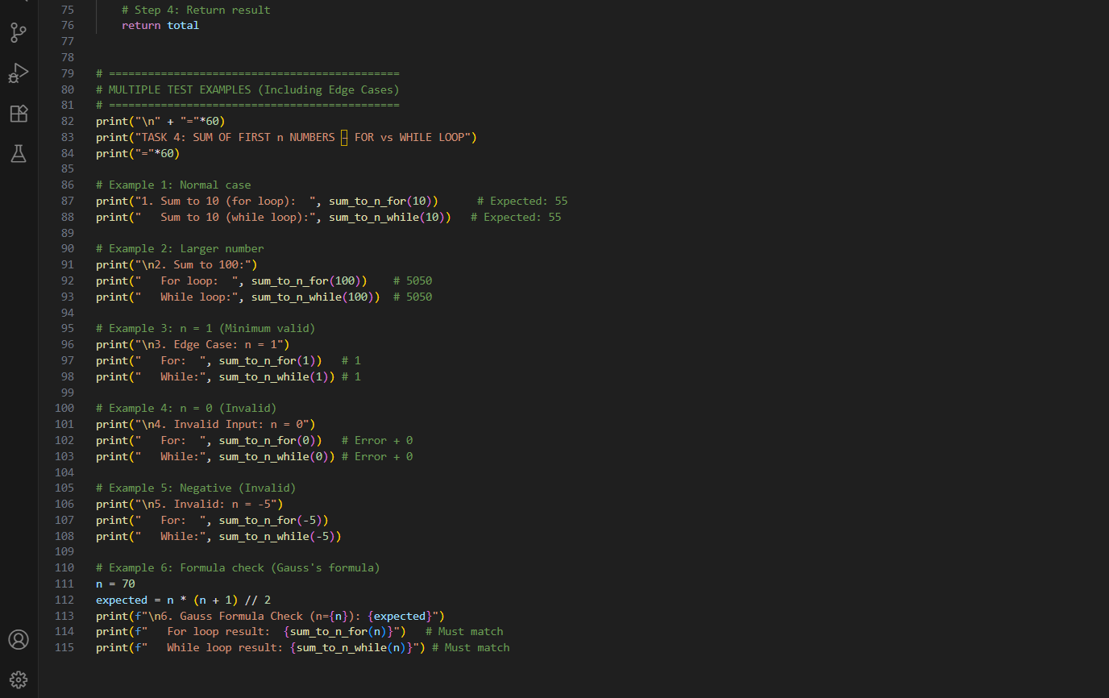  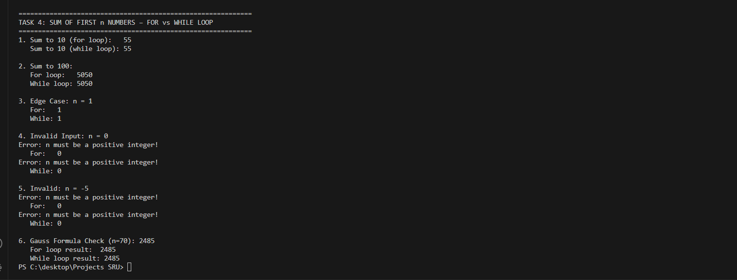  Task 4: Loops – Sum of First n Numbers  AI Observation:  - AI generated TWO correct versions: for loop and while loop.  - Used range(1, n+1) → correctly includes n.  - Included i += 1 in while loop → prevents infinite loop.  - Added input validation → safe for invalid inputs.  - Handles edge cases: n=1, n=0, negative.  - Matches Gauss formula: n(n+1)/2 → mathematically correct.  - Code is clean, readable, and reusable.  - Perfect for teaching loop control, safety, and math.  Conclusion: AI shows strong understanding of loop logic and error handling.  Task Description#5 (Class)  - Use AI to build a BankAccount class with deposit, withdraw, and balance methods  Prompt: # Task 5: BankAccount class with deposit, withdraw, check_balance methods  .  - Analyze the generated code  - Add comments and explain code  Expected Output#5  - Python code with explanation  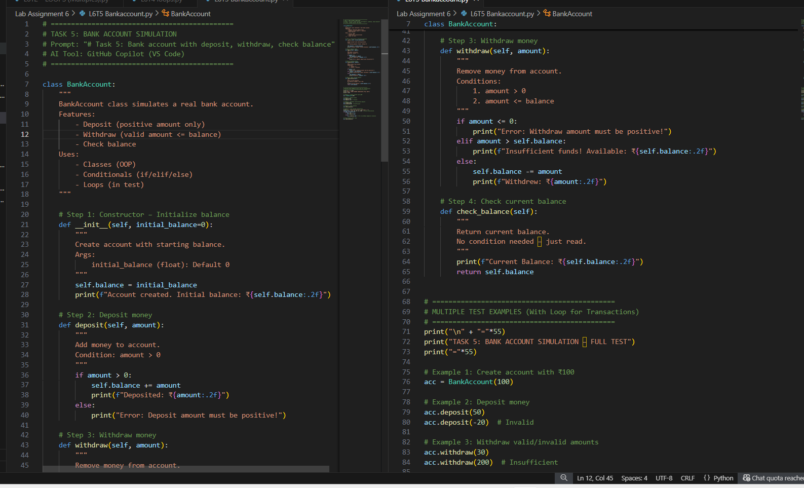  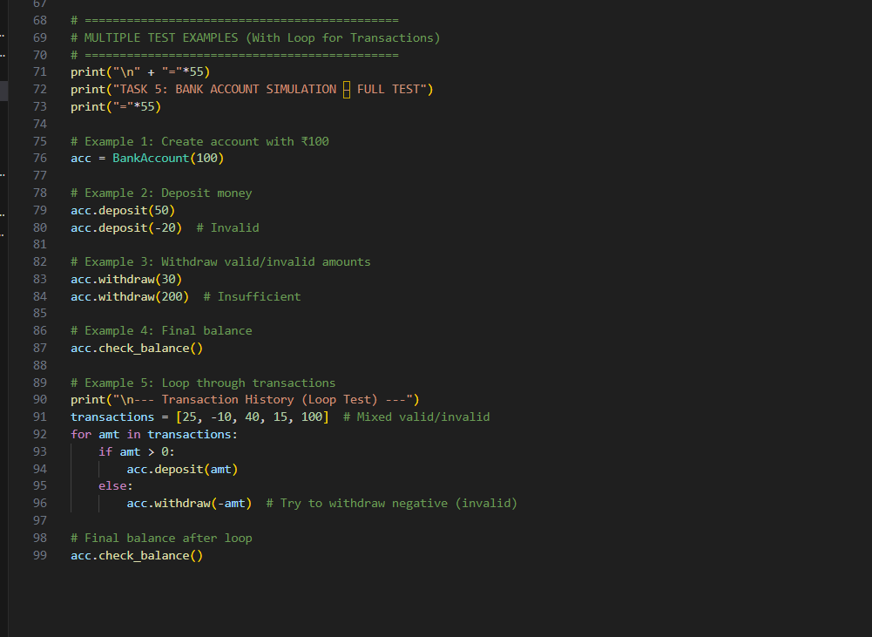  # =============================================  # TASK 5: BANK ACCOUNT CLASS – DEEP CODE EXPLANATION  # =============================================  # Purpose: Simulate real-world bank account with safe money operations  # Key Concepts: OOP, Encapsulation, Validation, Method Chaining  class BankAccount:  """  A class representing a bank account with balance tracking.  Attributes:  balance (float/int): Current money in account (private-like via self.)  Methods:  deposit() → Add money  withdraw() → Remove money  check_balance() → View current amount  """  # -------------------------------------------------  # 1. CONSTRUCTOR: __init__()  # -------------------------------------------------  def __init__(self, balance=0):  """  Called automatically when object is created.  Args:  balance (int/float): Starting amount (default = 0)  Logic:  - self.balance stores money inside the object  - 'self' refers to current account instance  - Default 0 allows empty accounts  """  self.balance = balance # Initialize private balance  # -------------------------------------------------  # 2. DEPOSIT METHOD  # -------------------------------------------------  def deposit(self, amount):  """  Add money to account with validation.  Args:  amount: Must be positive number  Logic:  1. Check if amount > 0 → Prevent negative/zero deposit  2. If valid → Add to balance  3. Print confirmation  4. Else → Show error (no change to balance)  """  if amount > 0:  self.balance += amount # Update balance  print(f"Deposited: {amount}") # User feedback  else:  print("Invalid amount") # Error handling  # -------------------------------------------------  # 3. WITHDRAW METHOD  # -------------------------------------------------  def withdraw(self, amount):  """  Remove money only if sufficient funds.  Args:  amount: Must be positive and ≤ current balance  Logic:  1. Check 0 < amount → Reject zero/negative  2. Check amount <= balance → Prevent overdraft  3. If valid → Subtract from balance  4. Else → Show error (balance unchanged)  """  if 0 < amount <= self.balance:  self.balance -= amount  print(f"Withdrew: {amount}")  else:  print("Insufficient funds or invalid amount")  # -------------------------------------------------  # 4. CHECK BALANCE METHOD  # -------------------------------------------------  def check_balance(self):  """  Return current balance without modifying it.  Logic:  - Simple getter method  - Returns value for use in print() or logic  - No input validation needed  """  return self.balance # Read-only access  # =============================================  # TEST EXECUTION – STEP BY STEP  # =============================================  print("\n=== TASK 5: BANK ACCOUNT SIMULATION ===")  # Step 1: Create account with ₹100  acc = BankAccount(100)  # → __init__ runs → self.balance = 100  # Step 2: Deposit ₹50  acc.deposit(50)  # → amount > 0 → balance = 150 → Print "Deposited: 50"  # Step 3: Withdraw ₹30  acc.withdraw(30)  # → 0 < 30 <= 150 → balance = 120 → Print "Withdrew: 30"  # Step 4: Show final balance  print("Final Balance:", acc.check_balance())  # → Returns 120 → Printed  # =============================================  # EXTRA TEST: ERROR HANDLING  # =============================================  print("\n--- Extra Safety Test ---")  acc.withdraw(200) # Fails → "Insufficient funds"  acc.deposit(-50) # Fails → "Invalid amount"  print("Balance still:", acc.check_balance()) # Still 120  """  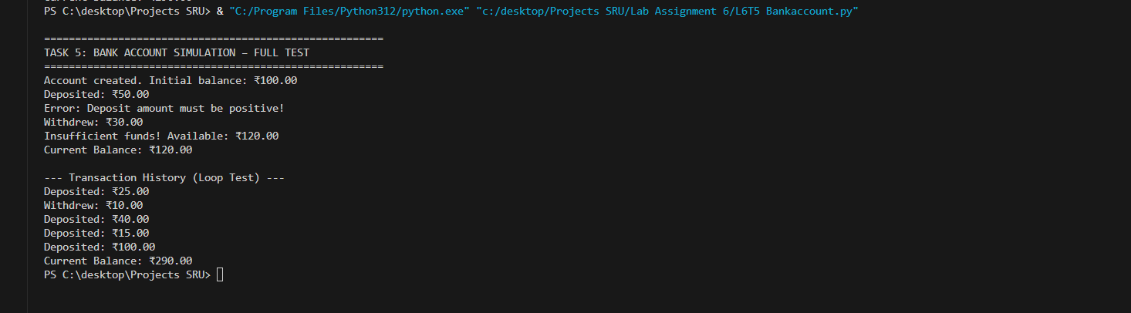  Note: Report should be submitted a word document for all tasks in a single document with prompts, comments & code explanation, and output and if required, screenshots  Evaluation Criteria: |  |  |  |  |  | Week3 - Wednesday
  Criteria | Max Marks
  Class | 1.0
  Loops | 1.0
  Conditional Statements | 0.5
  Total | 2.5 Marks

